**FIB NETWORK TOPOLOGY**

**Proposed network topology:**

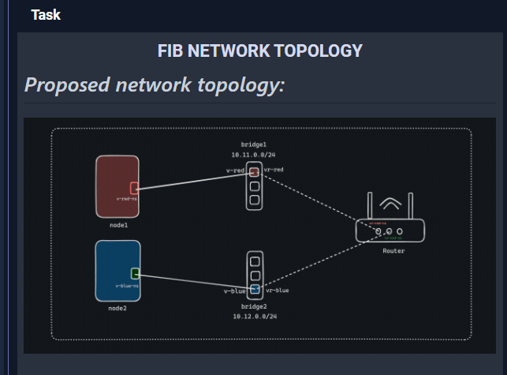

***How FIB network architecture generally works:***

1. **FIB Overview:**
   * The Forwarding Information Base (FIB) is a table used by routers to determine packet forwarding.
   * It contains mappings of destination network addresses to the next-hop router or interface.
2. **Populating the FIB:**
   * FIB entries are populated through routing protocols such as OSPF, RIP, and BGP.
   * These protocols exchange routing information among routers to build and update the FIB.
3. **Forwarding Decisions:**
   * When a router receives an incoming packet, it examines the destination IP address.
   * The router looks up the destination address in its FIB.
   * If a matching entry is found in the FIB, the router forwards the packet based on the next-hop information specified in the FIB entry.
   * If no matching entry is found, the router typically either drops the packet or forwards it to a default route if configured.

**Write a Makefile**

**Install some dependencies:**

sudo apt update

sudo apt install iproute2 -y

sudo apt install net-tools

sudo apt install iputils-ping -y

sudo apt install vim -y

sudo apt install make -y

Create a file:

vim Makefile

Try this one:

namespaces:

@ sudo ip netns add red

@ sudo ip netns add blue

@ sudo ip netns add router

bridges:

@ sudo ip link add br-red type bridge

@ sudo ip link add br-blue type bridge

@ sudo ip link set dev br-red up

@ sudo ip link set dev br-blue up

cables:

@ sudo ip link add v-red type veth peer name v-red-ns

@ sudo ip link add v-blue type veth peer name v-blue-ns

@ sudo ip link add vr-red type veth peer name vr-red-ns

@ sudo ip link add vr-blue type veth peer name vr-blue-ns

interfaces:

@ sudo ip link set v-red-ns netns red

@ sudo ip link set v-blue-ns netns blue

@ sudo ip link set v-red master br-red

@ sudo ip link set v-blue master br-blue

@ sudo ip link set vr-red master br-red

@ sudo ip link set vr-blue master br-blue

@ sudo ip link set vr-red-ns netns router

@ sudo ip link set vr-blue-ns netns router

ipaddr:

@ sudo ip netns exec red ip addr add 10.11.0.2/24 dev v-red-ns

@ sudo ip netns exec blue ip addr add 10.12.0.3/24 dev v-blue-ns

@ sudo ip netns exec router ip addr add 10.11.0.1/24 dev vr-red-ns

@ sudo ip netns exec router ip addr add 10.12.0.1/24 dev vr-blue-ns

state:

@ sudo ip netns exec red ip link set dev v-red-ns up

@ sudo ip netns exec blue ip link set dev v-blue-ns up

@ sudo ip netns exec router ip link set dev vr-red-ns up

@ sudo ip netns exec router ip link set dev vr-blue-ns up

@ sudo ip link set dev v-red up

@ sudo ip link set dev v-blue up

@ sudo ip link set dev vr-red up

@ sudo ip link set dev vr-blue up

routes:

@ sudo ip netns exec red ip route add default via 10.11.0.1

@ sudo ip netns exec blue ip route add default via 10.12.0.1

ping:

@ sudo ip netns exec red ping -c 4 10.12.0.3

forwarding:

@ sudo iptables --append FORWARD --in-interface br-red --jump ACCEPT

@ sudo iptables --append FORWARD --in-interface br-blue --jump ACCEPT

@ sudo iptables --append FORWARD --out-interface br-red --jump ACCEPT

@ sudo iptables --append FORWARD --out-interface br-blue --jump ACCEPT

delete:

@ sudo ip netns delete red

@ sudo ip netns delete blue

@ sudo ip netns delete router

@ sudo ip link delete br-red type bridge

@ sudo ip link delete br-blue type bridge

***How the FIB works in our environment:***

**1. Router Configuration**:

* In our setup, the **router** namespace is acting as a router between the **red** and **blue** namespaces.
* The router's FIB contains information about the next-hop IP addresses for each destination network.
* When a packet arrives at the router, it consults its FIB to determine the next-hop interface and IP address for the packet.

**Routing Table**:

* + The routing table in the **router** namespace contains the routing information used to populate the FIB.
  + Entries in the routing table specify the destination network (e.g., **10.11.0.0/24** for the **red** namespace and **10.12.0.0/24** for the **blue** namespace) and the next-hop IP address for each network.
  + The router uses this routing table to populate its FIB with the necessary forwarding information.

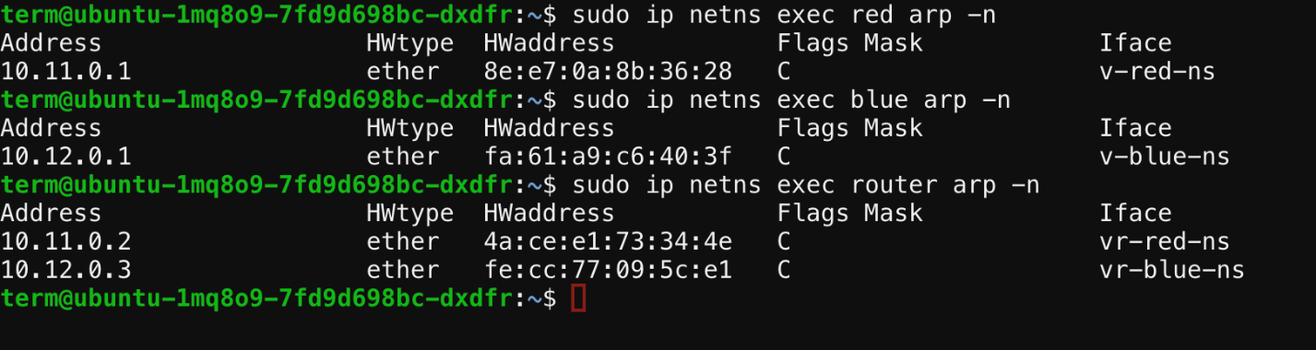*Mac Address table:*

***Routing table:***

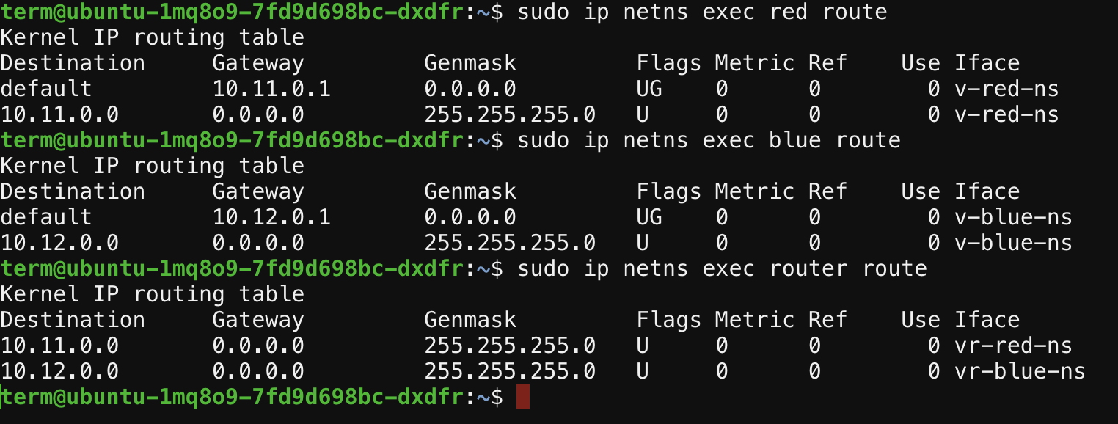

**Packet Forwarding**:

* When a packet arrives at the router, it performs a lookup in its FIB to determine the next-hop interface and IP address for the packet's destination.
* Based on the information in the FIB, the router forwards the packet to the appropriate interface.
* If the packet's destination is within the same network (e.g., from **red** to **router**), the router forwards the packet directly to the destination host without further routing.

**Connectivity:**

